Jaypee Institute of Information Technology, Noida-128
CN Lab (15B17CI571) Exercises
5th Semester – 2019 (Odd Semester)
Evaluation Scheme:-
Day to Day Evaluation + CN Lab Project: 60 Marks
Lab Test‐1: 20 Marks
Lab Test‐2: 20 Marks
Instructions for the Lab
- Students having Lab attendance <60%, will be awarded ZERO Marks in D2D marks.
- If a student is absent on the day of evaluation, will be awarded ZERO for that evaluation.
- Turn off your systems before leaving lab.

Lab 9

Objective: Implementation of AQM algorithms and compare its performance analysis.

Q. Consider the following network scenario given in Figure-1. Plot the graph for throughput, and loss-rate for AQM algorithms: Drop-tail vs RED. Consider the Bandwidth and propagation delay as given in Figure-1. There are four flow of connection: 1. S0 to D0 2. S1 to D1 3. S2 to D2 4. S3 to D3. The AQM algorithms: Drop-tail / RED are implemented at bottleneck link R1R2.

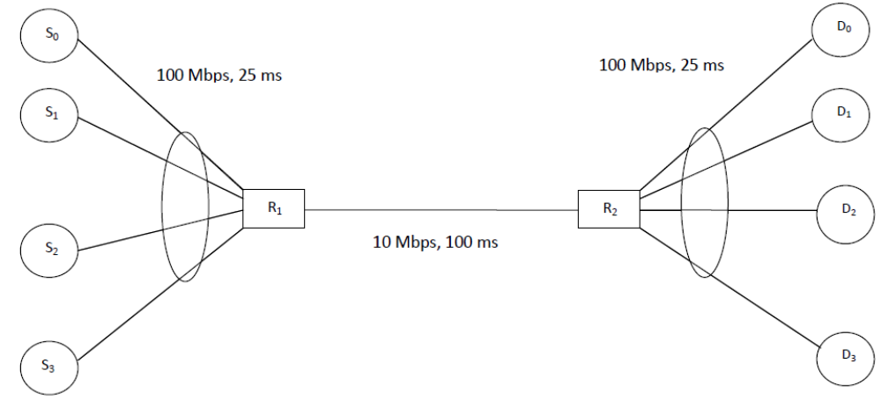
Figure-1

